At various times throughout Indian history, however, there have been individuals and
groups that have seen problems within the prevalent religious structures and have
sought to formulate new approaches and methods of expression for themselves. This
has been especially true for lower castes, women, and others who have existed on the
social and religious periphery and who have had to struggle to find a place where they
can fit in as legitimate participants. In the process, various unique approaches and
movements have arisen that have challenged the more restrictive aspects of the
orthodox traditions, and their actions have served to expand the diversity and breadth of
the tradition. The Ramnami Samaj, a low caste socio-religious movement in the state
of Chhattisgarh is a good example of such an approach. This chapter will take a look at
the origins and evolution of the organization and then look at how it has used its
practice of Hindu devotionalism to create room for its members and others who find
value in an antinomian form of devotionalism that is unlimited by orthodox parameters.
One of the more important and unique aspects of the movement is that is has utilized
and successfully become identified with deeply imbedded and revered elements of
Hindu spirituality, and it has used this identity to challenge high caste rules and
restrictions that were specifically meant to inhibit low caste and “Untouchable”
involvement in mainstream social and religious life. Since the movement is in the
twilight of its existence as a prevalent and dynamic influence in Chhattisgarh, I will
mostly be discussing what has occurred in the past with only some reference to the
present day.
Origins of the Ramnami Samaj
During the nineteenth and early twentieth centuries, central India was the home of
several important challenges to existing forms of political and religious authority in India.
The latter was stimulated primarily by the issue of caste restrictions on access to
religious knowledge and temples, and various movements had arisen to popularity in
response. The earliest of these challenges was the Kabirpanth. Although it had been
brought to the region by one of Kabir’s own disciples several centuries before, it gained
COVID-19 Aid effort in India – ServicePlace
With the ServicePlace Save-A-Life initiative, we were already working with multiple social service organizations with their health initiatives, when COVID-19 struck India with the force of a major tsunami. The enforced lockdown meant that the daily wage earners and the working poor suddenly had lost their source of income. House maids, carpenters, rickshaw pullers, thelawala ice cream sellers, street food sellers, restaurant workers, construction workers, drivers, gardeners – with families, ailing parents, little children – suddenly had no income coming in. Often they worked hundreds of miles away from their original homes and had no way of continuing to live in the cities as a lot of them sent their earnings to their homes. Now with no income and no way to get back home they were stuck.
Even the poor amongst the villagers who took their farm produce to the towns far away, suddenly had no means of transportation. If the products were handicrafts or other ‘non-essential’ goods, even the shops in the town were shut down. Thus, a large segment of the Indian population was in dire straits. Social support organizations pivoted to help wherever possible, and so did ServicePlace.
ServicePlace in India worked and continue to work with multiple organization who provide local support. In Kharagpur we work with St. John Ambulance, and have sponsored several food distribution projects – both in towns and villages (see pic). In Kolkata, where we currently reside, we have sponsored relief work partnering with the local police. A picture of Sarbari Chowdhury (VP, ServicePlace) during one of the food distribution efforts at Saltlake (Bidhnagar) is also included. Perhaps the most seriously affected are some of the people living on the fringes of society who earn their living by performing in the streets, and we were able to support them with raw rations by partnering with an organization called Born-To-Help.(see pics)
Since Debashis and Sarbari are in India at this time, we are seeing firsthand the collateral damage from this epidemic. The scale of the need is such that anything we do feels like a drop in the ocean. Another demographic that is suffering terribly are the elders in the community. Often with health problems, and no relatives nearby to support them, we have seen them tottering out - just to get the necessities of life. Many of the elderly need regular hospitals visits for medical care like dialysis or heart exams – and we are finding that many of them are developing COVID at the overworked hospitals and succumbing. Salt Lake, Kolkata, where we are now based has a huge elder population, and if the COVID shock waves continue, there will be a need for major social work in this very neighborhood.
Very impressed with the work the Police are doing – their presence, conctinencious checking, cordoning off affected areas, identifying and delivering food and other needs. Also impressive are the individual and NGOs who are raising lacks of rupees to provide aid to the affected – and their members partnering side by side with the police ensure the aid reaches the really needy.
Also, since we are here in India, we can make arrangements to remit donations made to ServicePlace.org directly to the serving organizations with zero overhead. In the longer term we ae forming a Kolkata-based sister organization for ServicePlace, and the proper permits are being applied for to allow relief efforts to be processed directly.
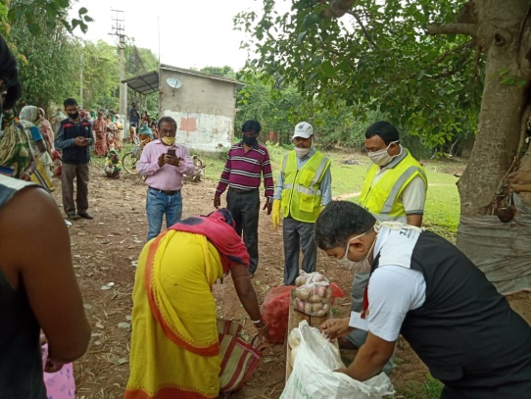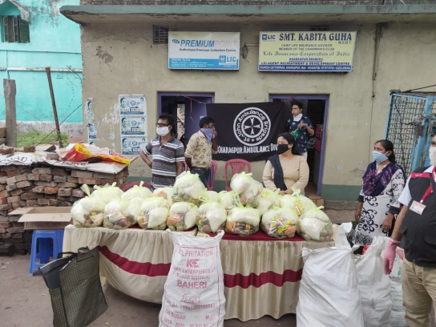
St. John’s Ambulance Kharagpur distributing uncooked rations to the needy.

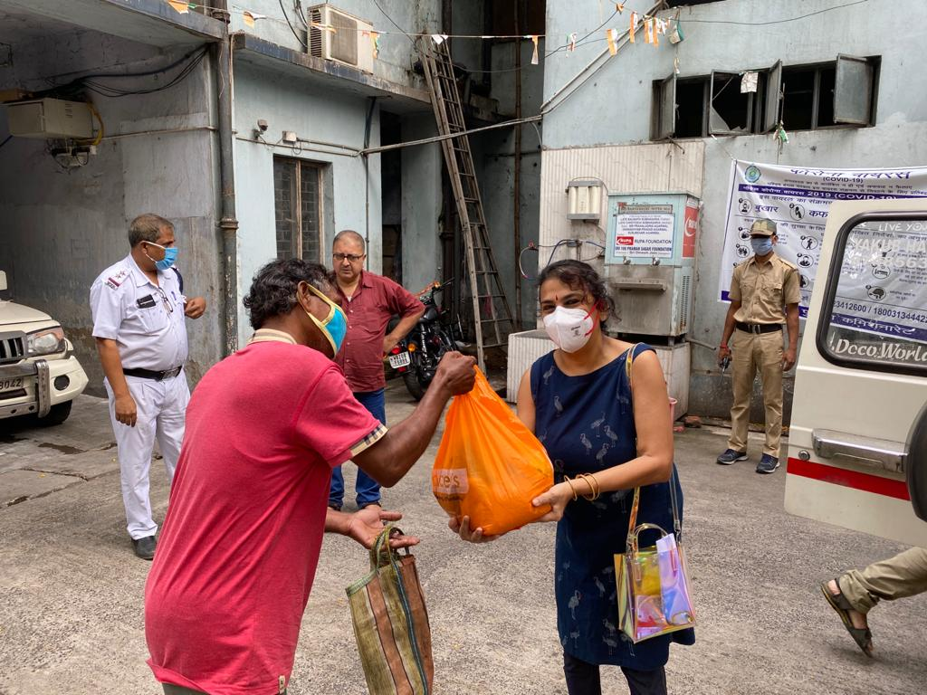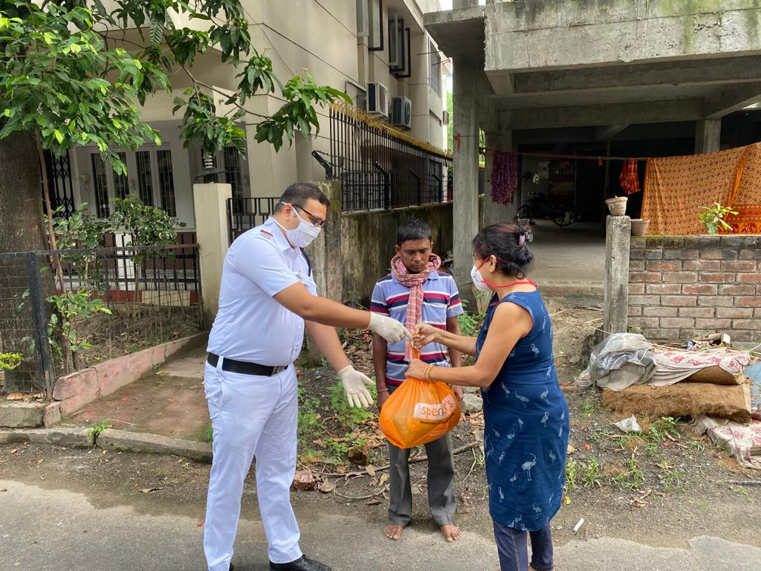
Partnering with Bidhannagar (SaltLake) Police to distribute uncooked rations to slum dwellers and rickshawala. One member of the needy family comes to the local police station, line up with social distancing, come forward one by one and are given aid packets. The Officer-in-charge and other policemen / policewomen are vigilant – if they see familiar faces who has been coming too often they do call them out to ask why the need for so much ration? A packet like this contains 2kg rice, 1 kg daal, 1 kg oil, 1 kg salt, packets of other spices. Sometimes they also contain flour and potates.
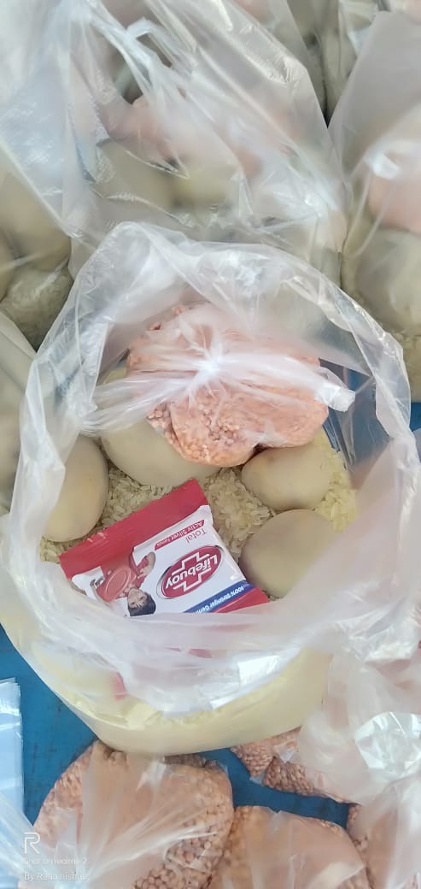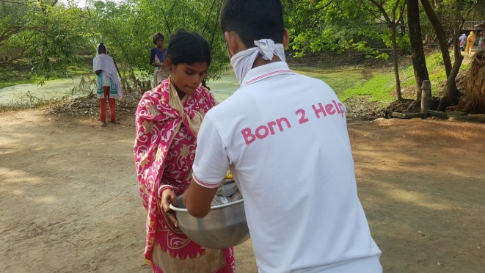
Born2Help distributing raw rations to the villagers
----------------------------------------------------------------------------------------------------------------------------------------
